LEAVE REQUEST
CLIENT REFERENCE:
URL: https://drauat.elitehrms.com
User Name : 0066
Password : M@ster
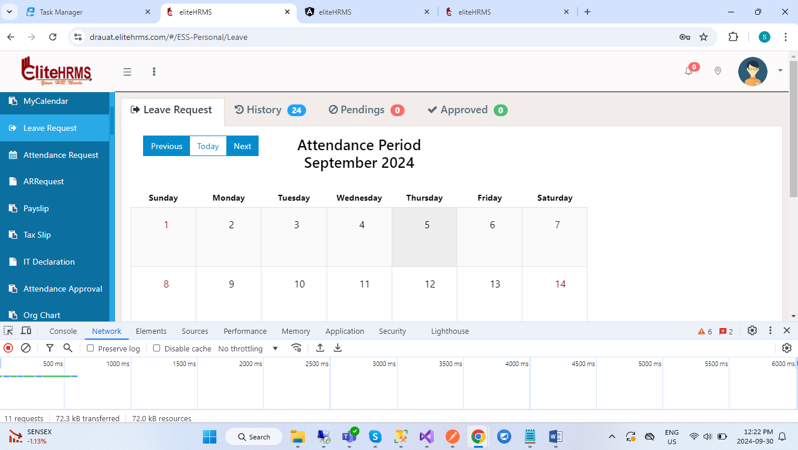
1.Intial screen have open to check Workflow, that call “WorkFlowApprover” api.
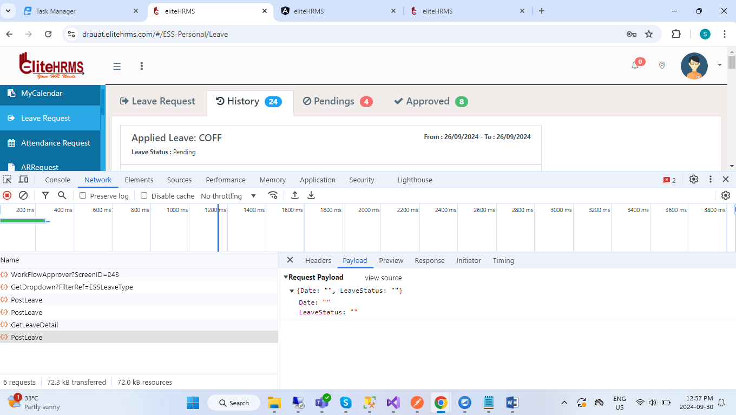
2.When click History, Pending & approved tab Call Same api “PostLeave”. But json have difference.

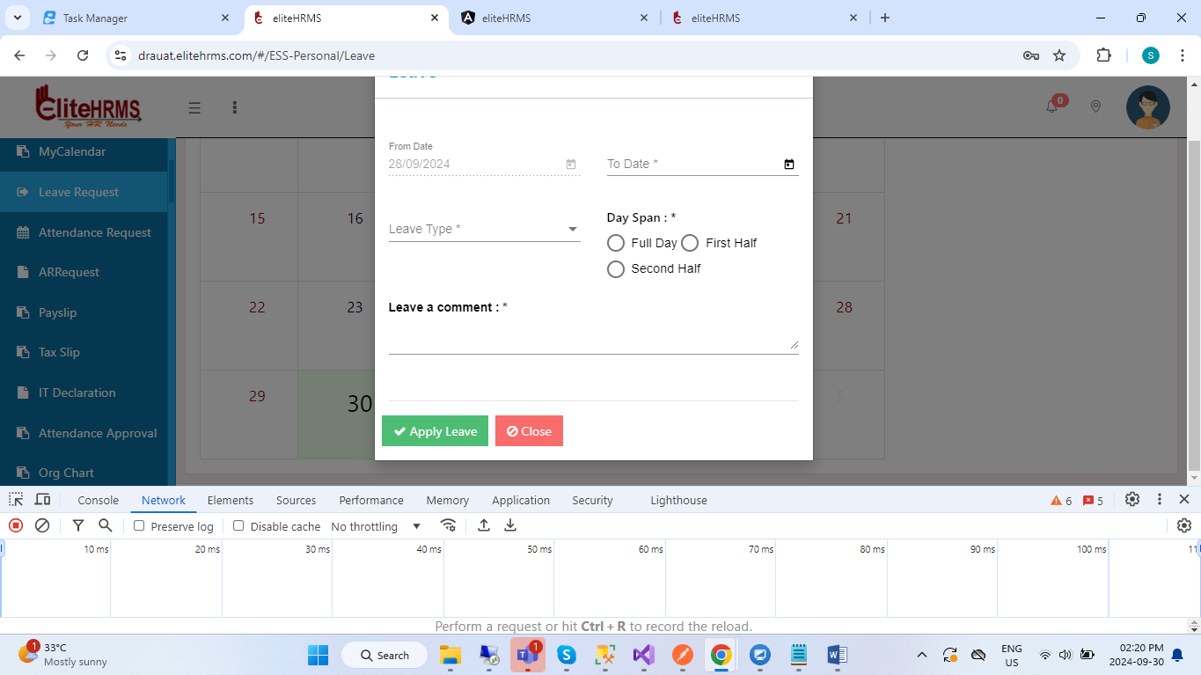
3.After enter all the data call “PostLeaveRequest” api.
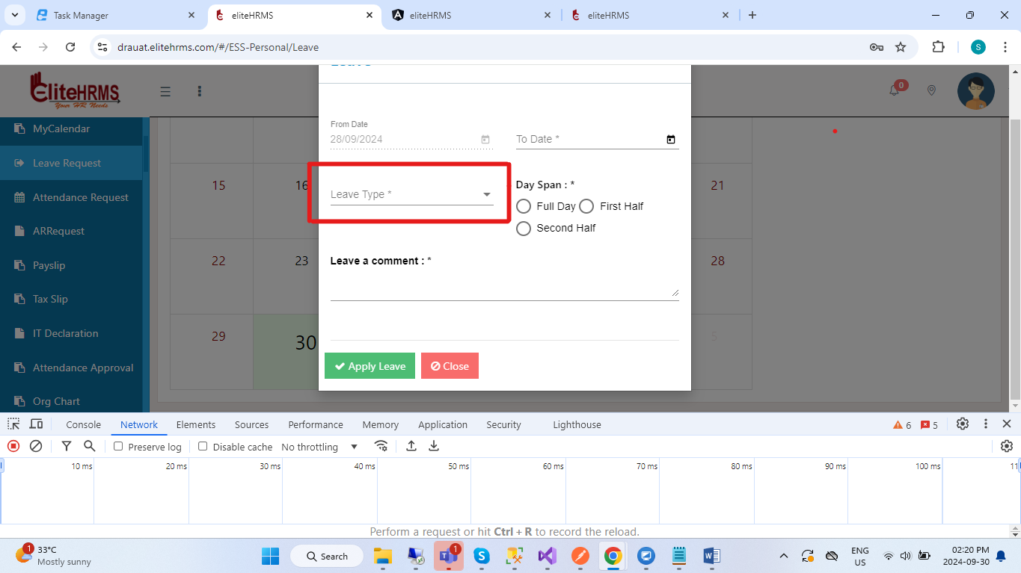
4.Leave types dropdown reference – LeaveType
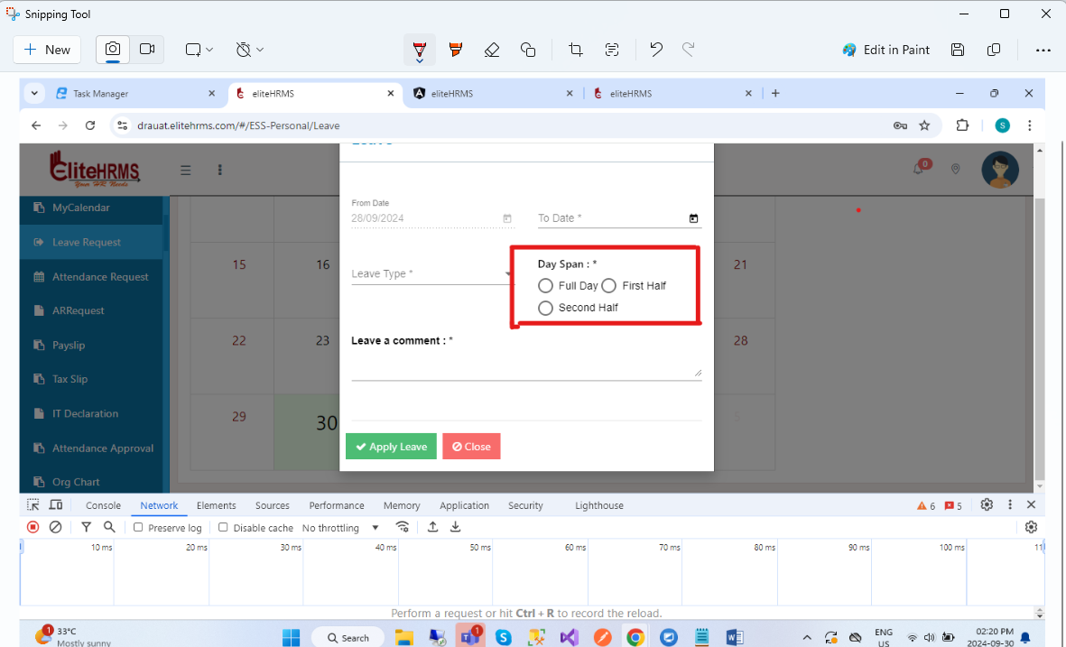
5.Dayspan reference - Day Span. In this Radio button value, you have send In ID for dynamic.

Post Api :
https://localhost:44349/api/Personal/PostLeaveRequest
{
"LeaveGUID": "7a6d493e-18ed-6705-e0a2-f37e26de1cc7",
"Fromdate": "2024-09-26",
"Todate": "2024-09-26",
"LeavetypeID": "3",
"DaySpanID": "6126",
"Leavestatus": "Draft",
"Remarks": "test",
"ScreenID": 243
}
{
"Response": {
"_status": "Success",
"_code": "111",
"_Source": "PostLeaveRequest",
"_Description": "Your leave has been applied Successfully...",
"_Details": "Workflow screen not added",
"_TransID": null,
"_Timestamp": "20240926123935"
},
"LeaveDetail": [],
"LeaveBalance": []
}
History Tab Get api:
https://localhost:44349/api/Personal/PostLeave
{
"Date": "",
"LeaveStatus": ""
}
{
"Response": {
"_status": "Success",
"_code": "111",
"_Source": "PostLeave",
"_Description": "Employee Attendance Details",
"_Details": "",
"_TransID": null,
"_Timestamp": "20240930125649"
},
"LeaveDetail": [
{
"LeaveGUID": null,
"Fromdate": "27/09/2024",
"Todate": "27/09/2024",
"CFromdate": "2024-09-27 12:00:00 AM",
"CTodate": "2024-09-27 12:00:00 AM",
"Leavetype": "CL",
"LeavetypeID": 2,
"DaySpanID": 3,
"DaySpan": "Full Day",
"NoofDay": "1",
"Remarks": "testtt",
"Leavestatus": "Pending",
"LeavestatusID": 6862,
"PeriodID": null,
"RequestGUID": "8fed962a-d295-433b-a895-8961da270f25",
"ScreenID": 0,
"Start": "27/09/2024",
"Title": "CL27/09/2024",
"Color": "CL",
"UploadFile": null
},
{
"LeaveGUID": null,
"Fromdate": "27/09/2024",
"Todate": "28/09/2024",
"CFromdate": "2024-09-27 12:00:00 AM",
"CTodate": "2024-09-28 12:00:00 AM",
"Leavetype": "CL",
"LeavetypeID": 2,
"DaySpanID": 3,
"DaySpan": "Full Day",
"NoofDay": "2",
"Remarks": "testtttt",
"Leavestatus": "Pending",
"LeavestatusID": 6862,
"PeriodID": null,
"RequestGUID": "ec419ff2-c0af-4b7c-8f23-82de54ac3f54",
"ScreenID": 0,
"Start": "27/09/2024",
"Title": "CL27/09/2024",
"Color": "CL",
"UploadFile": null
},
{
"LeaveGUID": null,
"Fromdate": "26/09/2024",
"Todate": "26/09/2024",
"CFromdate": "2024-09-26 12:00:00 AM",
"CTodate": "2024-09-26 12:00:00 AM",
"Leavetype": "LOP",
"LeavetypeID": 3,
"DaySpanID": 6126,
"DaySpan": "",
"NoofDay": "1",
"Remarks": "test",
"Leavestatus": "Pending",
"LeavestatusID": 6862,
"PeriodID": null,
"RequestGUID": "c0b38422-b5a6-4200-a8c3-50ec5b0fc2f4",
"ScreenID": 0,
"Start": "26/09/2024",
"Title": "LOP26/09/2024",
"Color": "LOP",
"UploadFile": null
},
{
"LeaveGUID": null,
"Fromdate": "10/09/2024",
"Todate": "10/09/2024",
"CFromdate": "2024-09-10 12:00:00 AM",
"CTodate": "2024-09-10 12:00:00 AM",
"Leavetype": "CL",
"LeavetypeID": 2,
"DaySpanID": 3,
"DaySpan": "Full Day",
"NoofDay": "1",
"Remarks": "",
"Leavestatus": "Approved",
"LeavestatusID": 6024,
"PeriodID": null,
"RequestGUID": "91070ad1-149e-d12a-065b-669b92fee8a4",
"ScreenID": 0,
"Start": "10/09/2024",
"Title": "CL10/09/2024",
"Color": "CL",
"UploadFile": null
},
{
"LeaveGUID": null,
"Fromdate": "20/09/2024",
"Todate": "20/09/2024",
"CFromdate": "2024-09-20 12:00:00 AM",
"CTodate": "2024-09-20 12:00:00 AM",
"Leavetype": "CL",
"LeavetypeID": 2,
"DaySpanID": 3,
"DaySpan": "Full Day",
"NoofDay": "1",
"Remarks": "",
"Leavestatus": "Approved",
"LeavestatusID": 6024,
"PeriodID": null,
"RequestGUID": "846e8931-2905-2ccd-a94c-35fc4159fb73",
"ScreenID": 0,
"Start": "20/09/2024",
"Title": "CL20/09/2024",
"Color": "CL",
"UploadFile": null
},
{
"LeaveGUID": null,
"Fromdate": "05/09/2024",
"Todate": "05/09/2024",
"CFromdate": "2024-09-05 12:00:00 AM",
"CTodate": "2024-09-05 12:00:00 AM",
"Leavetype": "CL",
"LeavetypeID": 2,
"DaySpanID": 3,
"DaySpan": "Full Day",
"NoofDay": "1",
"Remarks": "",
"Leavestatus": "Approved",
"LeavestatusID": 6024,
"PeriodID": null,
"RequestGUID": "1ebb3001-0b10-1321-a24a-90683cec8f09",
"ScreenID": 0,
"Start": "05/09/2024",
"Title": "CL05/09/2024",
"Color": "CL",
"UploadFile": null
},
{
"LeaveGUID": null,
"Fromdate": "01/09/2024",
"Todate": "02/09/2024",
"CFromdate": "2024-09-01 12:00:00 AM",
"CTodate": "2024-09-02 12:00:00 AM",
"Leavetype": "CL",
"LeavetypeID": 2,
"DaySpanID": 3,
"DaySpan": "Full Day",
"NoofDay": "2",
"Remarks": "",
"Leavestatus": "Approved",
"LeavestatusID": 6024,
"PeriodID": null,
"RequestGUID": "9f6e26a8-8d4a-8026-4d59-c8c8fbbc1ac6",
"ScreenID": 0,
"Start": "01/09/2024",
"Title": "CL01/09/2024",
"Color": "CL",
"UploadFile": null
}
],
"LeaveBalance": [
{
"LeaveType": "CL",
"LeaveBalance": "8.00"
},
{
"LeaveType": "PL",
"LeaveBalance": "10.00"
}
]
}
Pending Tab Get api:
https://localhost:44349/api/Personal/PostLeave
{
"Date": "",
"LeaveStatus": "Pending"
}
{
"Response": {
"_status": "Success",
"_code": "111",
"_Source": "PostLeave",
"_Description": "Employee Attendance Details",
"_Details": "",
"_TransID": null,
"_Timestamp": "20240930125933"
},
"LeaveDetail": [
{
"LeaveGUID": null,
"Fromdate": "27/09/2024",
"Todate": "27/09/2024",
"CFromdate": "2024-09-27 12:00:00 AM",
"CTodate": "2024-09-27 12:00:00 AM",
"Leavetype": "CL",
"LeavetypeID": 2,
"DaySpanID": 3,
"DaySpan": "Full Day",
"NoofDay": "1",
"Remarks": "testtt",
"Leavestatus": "Pending",
"LeavestatusID": 6862,
"PeriodID": null,
"RequestGUID": "8fed962a-d295-433b-a895-8961da270f25",
"ScreenID": 0,
"Start": "27/09/2024",
"Title": "CL27/09/2024",
"Color": "CL",
"UploadFile": null
},
{
"LeaveGUID": null,
"Fromdate": "27/09/2024",
"Todate": "28/09/2024",
"CFromdate": "2024-09-27 12:00:00 AM",
"CTodate": "2024-09-28 12:00:00 AM",
"Leavetype": "CL",
"LeavetypeID": 2,
"DaySpanID": 3,
"DaySpan": "Full Day",
"NoofDay": "2",
"Remarks": "testtttt",
"Leavestatus": "Pending",
"LeavestatusID": 6862,
"PeriodID": null,
"RequestGUID": "ec419ff2-c0af-4b7c-8f23-82de54ac3f54",
"ScreenID": 0,
"Start": "27/09/2024",
"Title": "CL27/09/2024",
"Color": "CL",
"UploadFile": null
},
{
"LeaveGUID": null,
"Fromdate": "26/09/2024",
"Todate": "26/09/2024",
"CFromdate": "2024-09-26 12:00:00 AM",
"CTodate": "2024-09-26 12:00:00 AM",
"Leavetype": "LOP",
"LeavetypeID": 3,
"DaySpanID": 6126,
"DaySpan": "",
"NoofDay": "1",
"Remarks": "test",
"Leavestatus": "Pending",
"LeavestatusID": 6862,
"PeriodID": null,
"RequestGUID": "c0b38422-b5a6-4200-a8c3-50ec5b0fc2f4",
"ScreenID": 0,
"Start": "26/09/2024",
"Title": "LOP26/09/2024",
"Color": "LOP",
"UploadFile": null
}
],
"LeaveBalance": [
{
"LeaveType": "CL",
"LeaveBalance": "8.00"
},
{
"LeaveType": "PL",
"LeaveBalance": "10.00"
}
]
}
Approved Tab Get api:
https://localhost:44349/api/Personal/PostLeave
{
"Date": "",
"LeaveStatus": "Approved"
}
{
"Response": {
"_status": "Success",
"_code": "111",
"_Source": "PostLeave",
"_Description": "Employee Attendance Details",
"_Details": "",
"_TransID": null,
"_Timestamp": "20240930141713"
},
"LeaveDetail": [
{
"LeaveGUID": null,
"Fromdate": "10/09/2024",
"Todate": "10/09/2024",
"CFromdate": "2024-09-10 12:00:00 AM",
"CTodate": "2024-09-10 12:00:00 AM",
"Leavetype": "CL",
"LeavetypeID": 2,
"DaySpanID": 3,
"DaySpan": "Full Day",
"NoofDay": "1",
"Remarks": "",
"Leavestatus": "Approved",
"LeavestatusID": 6024,
"PeriodID": null,
"RequestGUID": "91070ad1-149e-d12a-065b-669b92fee8a4",
"ScreenID": 0,
"Start": "10/09/2024",
"Title": "CL10/09/2024",
"Color": "CL",
"UploadFile": null
},
{
"LeaveGUID": null,
"Fromdate": "20/09/2024",
"Todate": "20/09/2024",
"CFromdate": "2024-09-20 12:00:00 AM",
"CTodate": "2024-09-20 12:00:00 AM",
"Leavetype": "CL",
"LeavetypeID": 2,
"DaySpanID": 3,
"DaySpan": "Full Day",
"NoofDay": "1",
"Remarks": "",
"Leavestatus": "Approved",
"LeavestatusID": 6024,
"PeriodID": null,
"RequestGUID": "846e8931-2905-2ccd-a94c-35fc4159fb73",
"ScreenID": 0,
"Start": "20/09/2024",
"Title": "CL20/09/2024",
"Color": "CL",
"UploadFile": null
},
{
"LeaveGUID": null,
"Fromdate": "05/09/2024",
"Todate": "05/09/2024",
"CFromdate": "2024-09-05 12:00:00 AM",
"CTodate": "2024-09-05 12:00:00 AM",
"Leavetype": "CL",
"LeavetypeID": 2,
"DaySpanID": 3,
"DaySpan": "Full Day",
"NoofDay": "1",
"Remarks": "",
"Leavestatus": "Approved",
"LeavestatusID": 6024,
"PeriodID": null,
"RequestGUID": "1ebb3001-0b10-1321-a24a-90683cec8f09",
"ScreenID": 0,
"Start": "05/09/2024",
"Title": "CL05/09/2024",
"Color": "CL",
"UploadFile": null
},
{
"LeaveGUID": null,
"Fromdate": "01/09/2024",
"Todate": "02/09/2024",
"CFromdate": "2024-09-01 12:00:00 AM",
"CTodate": "2024-09-02 12:00:00 AM",
"Leavetype": "CL",
"LeavetypeID": 2,
"DaySpanID": 3,
"DaySpan": "Full Day",
"NoofDay": "2",
"Remarks": "",
"Leavestatus": "Approved",
"LeavestatusID": 6024,
"PeriodID": null,
"RequestGUID": "9f6e26a8-8d4a-8026-4d59-c8c8fbbc1ac6",
"ScreenID": 0,
"Start": "01/09/2024",
"Title": "CL01/09/2024",
"Color": "CL",
"UploadFile": null
}
],
"LeaveBalance": [
{
"LeaveType": "CL",
"LeaveBalance": "8.00"
},
{
"LeaveType": "PL",
"LeaveBalance": "10.00"
}
]
}
Week off & Holiday details Get api:
https://localhost:44349/api/Personal/GetLeaveDetail
{
"Response": {
"_status": "Success",
"_code": "111",
"_Source": "GetLeaveDetail",
"_Description": "Employee Leave Details...",
"_Details": "",
"_TransID": null,
"_Timestamp": "20240925122724"
},
"Leave": [
{
"Date": "01/01/2024",
"ShiftName": "Week Off"
},
{
"Date": "02/01/2024",
"ShiftName": "Week Off"
},
{
"Date": "03/01/2024",
"ShiftName": "Week Off"
},
{
"Date": "04/01/2024",
"ShiftName": "Week Off"
},
{
"Date": "05/01/2024",
"ShiftName": "Week Off"
},
{
"Date": "06/01/2024",
"ShiftName": "Week Off"
},
{
"Date": "07/01/2024",
"ShiftName": "Week Off"
},
{
"Date": "08/01/2024",
"ShiftName": "Week Off"
},
{
"Date": "09/01/2024",
"ShiftName": "Week Off"
},
{
"Date": "10/01/2024",
"ShiftName": "Week Off"
},
{
"Date": "11/01/2024",
"ShiftName": "Week Off"
},
{
"Date": "12/01/2024",
"ShiftName": "Week Off"
},
{
"Date": "13/01/2024",
"ShiftName": "Week Off"
},
{
"Date": "14/01/2024",
"ShiftName": "Week Off"
},
{
"Date": "15/01/2024",
"ShiftName": "Week Off"
},
{
"Date": "16/01/2024",
"ShiftName": "Week Off"
},
{
"Date": "17/01/2024",
"ShiftName": "Week Off"
},
{
"Date": "18/01/2024",
"ShiftName": "Week Off"
},
{
"Date": "19/01/2024",
"ShiftName": "Week Off"
},
{
"Date": "20/01/2024",
"ShiftName": "Week Off"
},
{
"Date": "21/01/2024",
"ShiftName": "Week Off"
},
{
"Date": "22/01/2024",
"ShiftName": "Week Off"
},
{
"Date": "23/01/2024",
"ShiftName": "Week Off"
},
{
"Date": "24/01/2024",
"ShiftName": "Week Off"
},
{
"Date": "25/01/2024",
"ShiftName": "Week Off"
},
{
"Date": "26/01/2024",
"ShiftName": "Week Off"
},
{
"Date": "27/01/2024",
"ShiftName": "Week Off"
},
{
"Date": "28/01/2024",
"ShiftName": "Week Off"
},
{
"Date": "29/01/2024",
"ShiftName": "Week Off"
},
{
"Date": "30/01/2024",
"ShiftName": "Week Off"
},
{
"Date": "31/01/2024",
"ShiftName": "Week Off"
}
],
"LeaveStatus": [],
"ProbationChecks": []
}

